Genome Browser
Homework for course Bioinformatics
By 黄悉然
- Source data
  - Data loaded from T2_THA2.bam and THA2-bwa.bam;
  - You may view complete data in this folder.
- Screenshots from IGV
  - Used genome browser IGV for visualization;
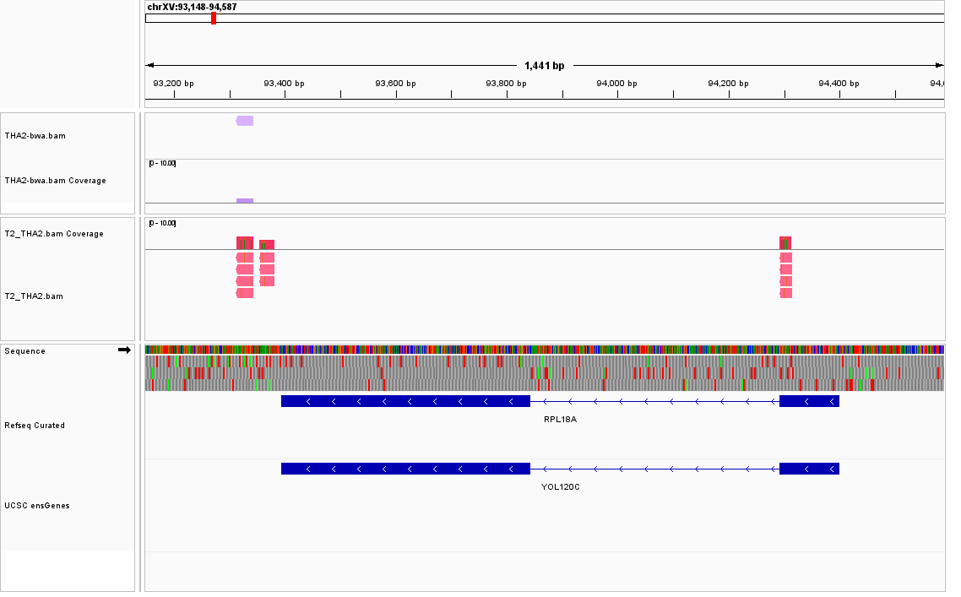
  - You may view png file here;
  - The figure captures alignment at gene RPL18A and YOL120C on chromosome XV in sacCer3 reference genome.

